**Task No. 1:** Complete the table by solving the bitwise instruction of all Logical gates. Add the code and output of the logical gates to show solution of MASK BITS given in the table.

**Solution:**

|  |  |  |
| --- | --- | --- |
| **Logic** | **Mask Bits** | |
|  | **0** | **1** |
| **AND** | 0 | 63 |
| **OR** | 63 | -1 |
| **NOT** | -64 | -64 |
| **XOR** | 63 | -64 |
| **XNOR** | -64 | 63 |
| **NOR** | -64 | 0 |
| **NAND** | -1 | -64 |

**AND WITH MASK 1**

**Solution**

.data

num1:.asciiz "Enter number 1 : "

result:.asciiz"The Result is : "

.text

.globl main

main:

li $t1,0xffffffff

li $v0,4

la $a0,num1

syscall

li $v0,5

syscall

move $t0,$v0

li $v0,4

****la $a0,result

syscall

and $t2,$t0,$t1

li $v0,1

move $a0,$t2

syscall

li $v0,10

syscall

**Output**

**AND WITH MASK 0**

**Solution**

.data

num1:.asciiz "Enter number 1 : "

result:.asciiz"The Result is : "

.text

.globl main

main:

#li $t1,0xffffffff

li $t1,0x000000000

li $v0,4

la $a0,num1

syscall

li $v0,5

syscall

move $t0,$v0

li $v0,4

la $a0,result

syscall

and $t2,$t0,$t1

li $v0,1

move $a0,$t2

syscall

li $v0,10

syscall

**Output**

**OR WITH MASK 1**

**Solution**

.data

num1:.asciiz "Enter number 1 : "

result:.asciiz"The Result is : "

.text

.globl main

main:

li $t1,0xffffffff

li $v0,4

la $a0,num1

syscall

li $v0,5

syscall

move $t0,$v0

li $v0,4

la $a0,result

syscall

or $t2,$t0,$t1

li $v0,1

move $a0,$t2

syscall

li $v0,10

syscall

**Output**

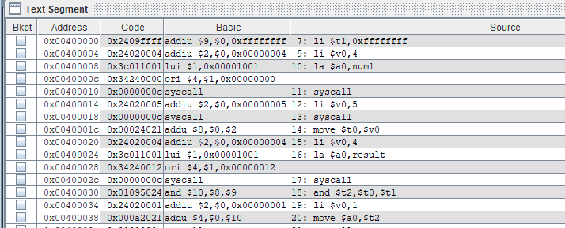

**OR WITH MASK 0**

**Solution**

.data

num1:.asciiz "Enter number 1 : "

result:.asciiz"The Result is : "

.text

.globl main

main:

li $t1,0x000000000

li $v0,4

la $a0,num1

syscall

li $v0,5

syscall

move $t0,$v0

li $v0,4

la $a0,result

syscall

or $t2,$t0,$t1

li $v0,1

move $a0,$t2

syscall

li $v0,10

syscall

**Output**

**NOT Bitwise Operator**

**Solution**

.data

num1:.asciiz "Enter number 1 : "

result:.asciiz"The Result is : "

.text

.globl main

main:

#li $t1,0xffffffff

#li $t1,0x000000000

li $v0,4

la $a0,num1

syscall

li $v0,5

syscall

move $t0,$v0

li $v0,4

la $a0,result

syscall

not $t2,$t0

li $v0,1

move $a0,$t2

syscall

li $v0,10

syscall

**Output**

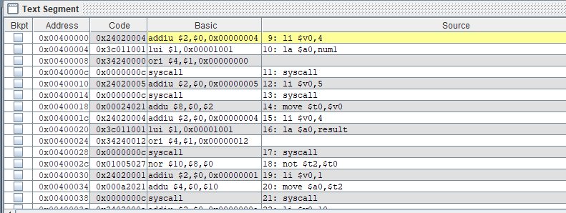

**XOR WITH MASK 1**

**Solution**

.data

num1:.asciiz "Enter number 1 : "

result:.asciiz"The Result is : "

.text

.globl main

main:

li $t1,0xffffffff

#li $t1,0x000000000

li $v0,4

la $a0,num1

syscall

li $v0,5

syscall

move $t0,$v0

li $v0,4

la $a0,result

syscall

xor $t2,$t0,$t1

li $v0,1

move $a0,$t2

syscall

li $v0,10

syscall

**Output**

**XOR WITH MASK 0**

**Solution**

.data

num1:.asciiz "Enter number 1 : "

result:.asciiz"The Result is : "

.text

.globl main

main:

li $t1,0x000000000

li $v0,4

la $a0,num1

syscall

li $v0,5

syscall

move $t0,$v0

li $v0,4

la $a0,result

syscall

xor $t2,$t0,$t1

li $v0,1

move $a0,$t2

syscall

li $v0,10

syscall

**Output**

**XNOR WITH MASK 1**

**Solution**

.data

mess1:.asciiz "Enter Your Number : "

res: .asciiz "Your Result Is :"

.text

main:

li $t0,0xffffffff

#li $t0,0x00000000

li $v0,4

la $a0,mess1

syscall

li $v0,5

syscall

move $t1,$v0

xor $t2,$t0,$t1

not $t3,$t2

li $v0,4

la $a0,res

syscall

move $a0,$t3

li $v0,1

syscall

li $v0,10

syscall

**Output**

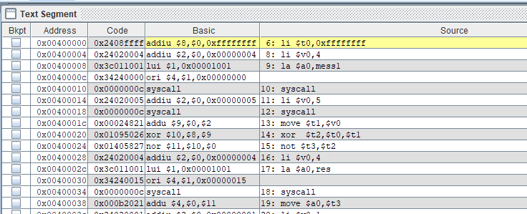

**XNOR WITH MASK 0**

**Solution**

.data

mess1:.asciiz "Enter Your Number : "

res: .asciiz "Your Result Is :"

.text

main:

li $t0,0x00000000

li $v0,4

la $a0,mess1

syscall

li $v0,5

syscall

move $t1,$v0

xor $t2,$t0,$t1

not $t3,$t2

li $v0,4

la $a0,res

syscall

move $a0,$t3

li $v0,1

syscall

li $v0,10

syscall

**Output**

**NOR WITH MASK 1**

**Solution**

.data

num1:.asciiz "Enter number 1 : "

result:.asciiz"The Result is : "

.text

.globl main

main:

li $t1,0xffffffff

#li $t1,0x000000000

li $v0,4

la $a0,num1

syscall

li $v0,5

syscall

move $t0,$v0

li $v0,4

la $a0,result

syscall

nor $t2,$t0,$t1

li $v0,1

move $a0,$t2

syscall

li $v0,10

syscall

**Output**

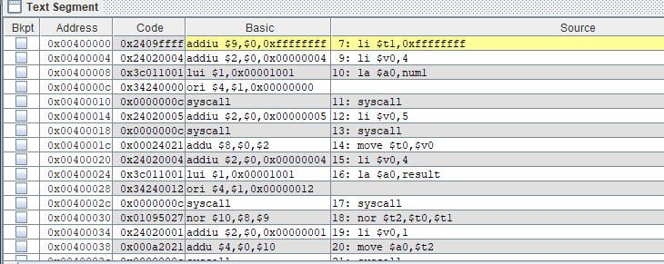

**NOR WITH MASK 0**

**Solution**

.data

num1:.asciiz "Enter number 1 : "

result:.asciiz"The Result is : "

.text

.globl main

main:

li $t1,0x000000000

li $v0,4

la $a0,num1

syscall

li $v0,5

syscall

move $t0,$v0

li $v0,4

la $a0,result

syscall

nor $t2,$t0,$t1

li $v0,1

move $a0,$t2

syscall

li $v0,10

syscall

**Output**

**NAND WITH MASK 1**

**Solution**

.data

mess1:.asciiz "Enter Your Number : "

res: .asciiz "Your Result Is :"

.text

main:

li $t0,0xffffffff

li $v0,4

la $a0,mess1

syscall

li $v0,5

syscall

move $t1,$v0

and $t2,$t0,$t1

not $t3,$t2

li $v0,4

la $a0,res

syscall

move $a0,$t3

li $v0,1

syscall

li $v0,10

syscall

**Output**

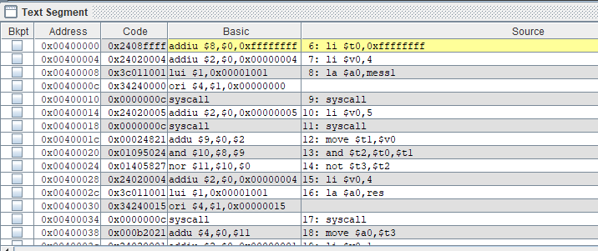

**NAND WITH MASK 0**

**Solution**

.data

mess1:.asciiz "Enter Your Number : "

res: .asciiz "Your Result Is :"

.text

main:

li $t0,0x00000000

li $v0,4

la $a0,mess1

syscall

li $v0,5

syscall

move $t1,$v0

and $t2,$t0,$t1

not $t3,$t2

li $v0,4

la $a0,res

syscall

move $a0,$t3

li $v0,1

syscall

li $v0,10

syscall

**Output**

